# PROJECT 06-03

## Intensity Slicing

1. Implement intensity slicing, with the characteristic that you can specify different ranges of gray-level values for the input image and your program will output an RGB image whose pixels have a specified color. You can set the colors in color palette.
2. Process the above images with your program with different ranges (8 for (1), 3 for (2), 20 for (3)).

# 

* 1. picker_phantom.tif (2)weld-original.tif

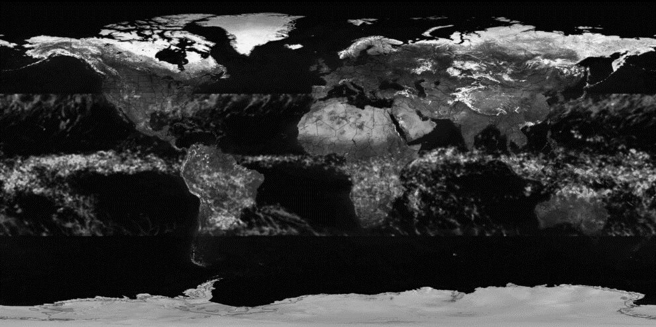

(3) tropical_rain_grayscale.tif

# PROJECT 06-04

## Color complement

Use the complement function (as show in following figure 6.33(b)) of R,G,B components and H, S, I components respectively to implement the color image complement of image ‘strawberries’ .

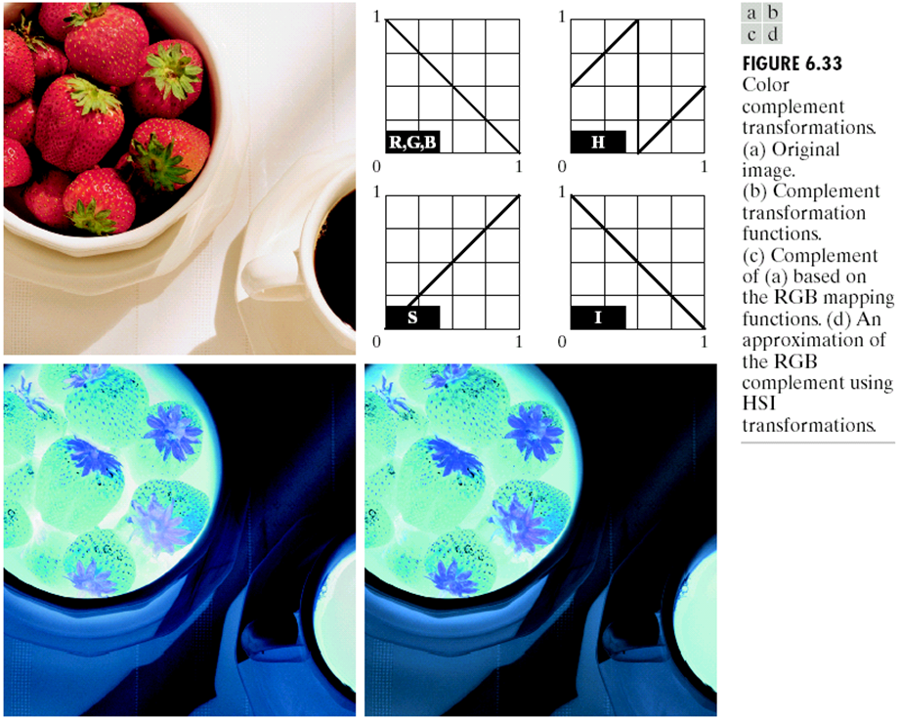

# PROJECT 06-05

## Color slicing

Using the following two equation to implement the color slicing on image ‘strawberries’ where n=3 denotes the Red, Green and Blue component. Set W= 0.2549, R=0.1765, a = (0.6863, 0.1608, 0.1922). Pixels outside the cube and sphere were replaced by color (0.5, 0.5, 0.5)

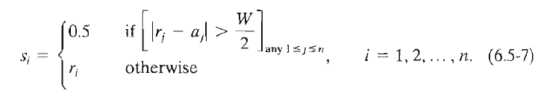

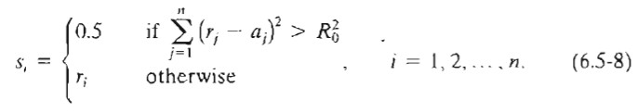

# PROJECT 06-06

## Histogram Processing on Color Images

The following image “Fig0637(a)(caster_stand_original)” is a color image of a caster stand containing cruets and shakers.

1. Demonstrate the histogram of its intensity component
2. Implement the Histogram Equalizing on the intensity component, without altering the hue and saturation. Comparing the result to the original image.
3. Further increase the image's saturation component and compare the result to (b)
4. Demonstrate the histogram of its intensity component of the processed image after (c) and compare the distribution to (a).